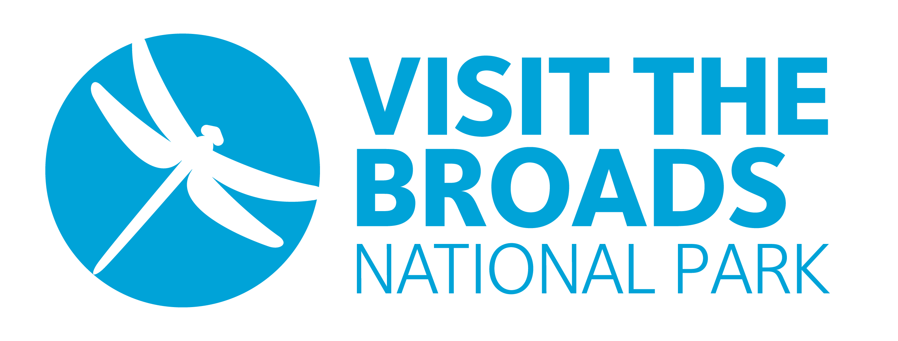
Visit the Broads Annual Membership Booking Form
Business Name: | Click to add text
Main Contact: | Click to add text
Address: | Click to add text
Click to add text |  | Postcode: | Click to add text
Telephone: | Click to add text | Email: | Click to add text
Invoice Email: | Click to add text
Business Type | Click to add text
Business Activity | Click to add text

We would like to subscribe to the Visit the Broads Annual Membership shown below.
Membership of Visit the Broads renews automatically each year unless you notify us of cancellation. Payment is taken by Direct Debit. The membership year runs from 1 October, with renewal notices issued in mid-September.

Annual Turnover of Business | Annual Membership Fee | Please Tick
Under £100,000 & not-for-profit organisations | £150 + VAT
Local & District Councils | £200 + VAT
£100,000 - £500,000 | £250 + VAT
Member to Member Business | £250 + VAT
Over £500,000 (or multiple website listings) | £350 + VAT

Businesses who wish to include more company listings – i.e. holiday parks/sub brands/pub chains - will have up to 3 listings included in the top tier price. These businesses must be reported to Companies House under same company accounts as the main member. Subsequent website/app listings to the 3 included will be charged at £25 each.

Members on all levels of subscriptions receive the same amount of marketing support from Visit The Broads.

TOTAL TO BE INVOICED (+ VAT) | £ Click to add text

Signed | Click to add text | Date | Click to add text
Name | Click to add text | Position | Click to add text

Please return the completed form to: membership@visitthebroads.co.uk
IMPORTANT - After we receive your completed booking form, you will get an email from GoCardless inviting you to set up a Direct Debit. Once this is in place, we will issue an invoice confirming the amount and payment date. The payment will then be collected automatically a few days later. You can cancel your Direct Debit at any time.

