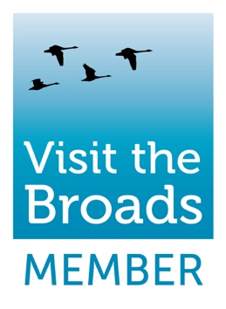
Visit the Broads Annual Membership
Joining Visit the Broads has never been easier and means that you will receive all of the following benefits.

- Premium Website Listing - 12 months listing on visitthebroads.co.uk, the official visitor website for the Broads National Park, with over 243,000 visitors and 885,000 page views in 2021.

- Featured on Social Media – With an audience of over 18,000, we like to include our members on our Social Media channels (Twitter, Facebook and Instagram) wherever possible.

- Visitor Newsletter – Feature in one of 12 visitor newsletters, sent to over 4000 subscribers.

- Advertise in the Visit the Broads Pocket Guide - As a member of Visit the Broads you will have the opportunity to advertise in the Visit the Broads Pocket Guide. (Digital only for 2021)

- Promotional Competitions - Competitions are a great way to raise the profile of your business, Visit the Broads runs regular competitions through our newsletters and social media channels.

- Third-Party Marketing – Visit the Broads works with third party organisations such as Visit Britain, Visit East of England, The Broads Authority and National Parks UK. This gives us the opportunity to promote the area and our members businesses outside of the region.

- Press & PR - As a member you will be notified of the latest media requests, have opportunities host press trips, submit articles or provide quotes for news stories.

- Photo Gallery - Members have access to a bank of lifestyle photographs and images of the Broads, commissioned by Visit the Broads which are available for use by members.

- Monthly Members Newsletter – Latest industry news and information on everything we are working on at Visit the Broads.

- Market Research & Industry insights - Access to up-to-date market research and analysis to help inform your business decision making. For practical tips, legal obligations and local support to help your tourism business to grow View the Visit Britain Advice Hub

- Member Logo - Use of Visit the Broads logo on your website and on marketing collateral. By using our logos customers will recognise that you offer a quality product or service.

- Networking – We hold two members’ meetings each year. These are a great opportunity to hear some inspiring speakers and share ideas and information with other visit the Broads members.

- Exclusive Workshops - We offer exclusive workshops and events for members in conjunction with our corporate partners.

- Discounted Services – Get improved purchasing terms from our corporate trade partnership programmes.

- Support Love the Broads – Help to protect the Broads through this registered charity and improve your corporate social responsibility rating by demonstrating a positive impact on the Broads More Info

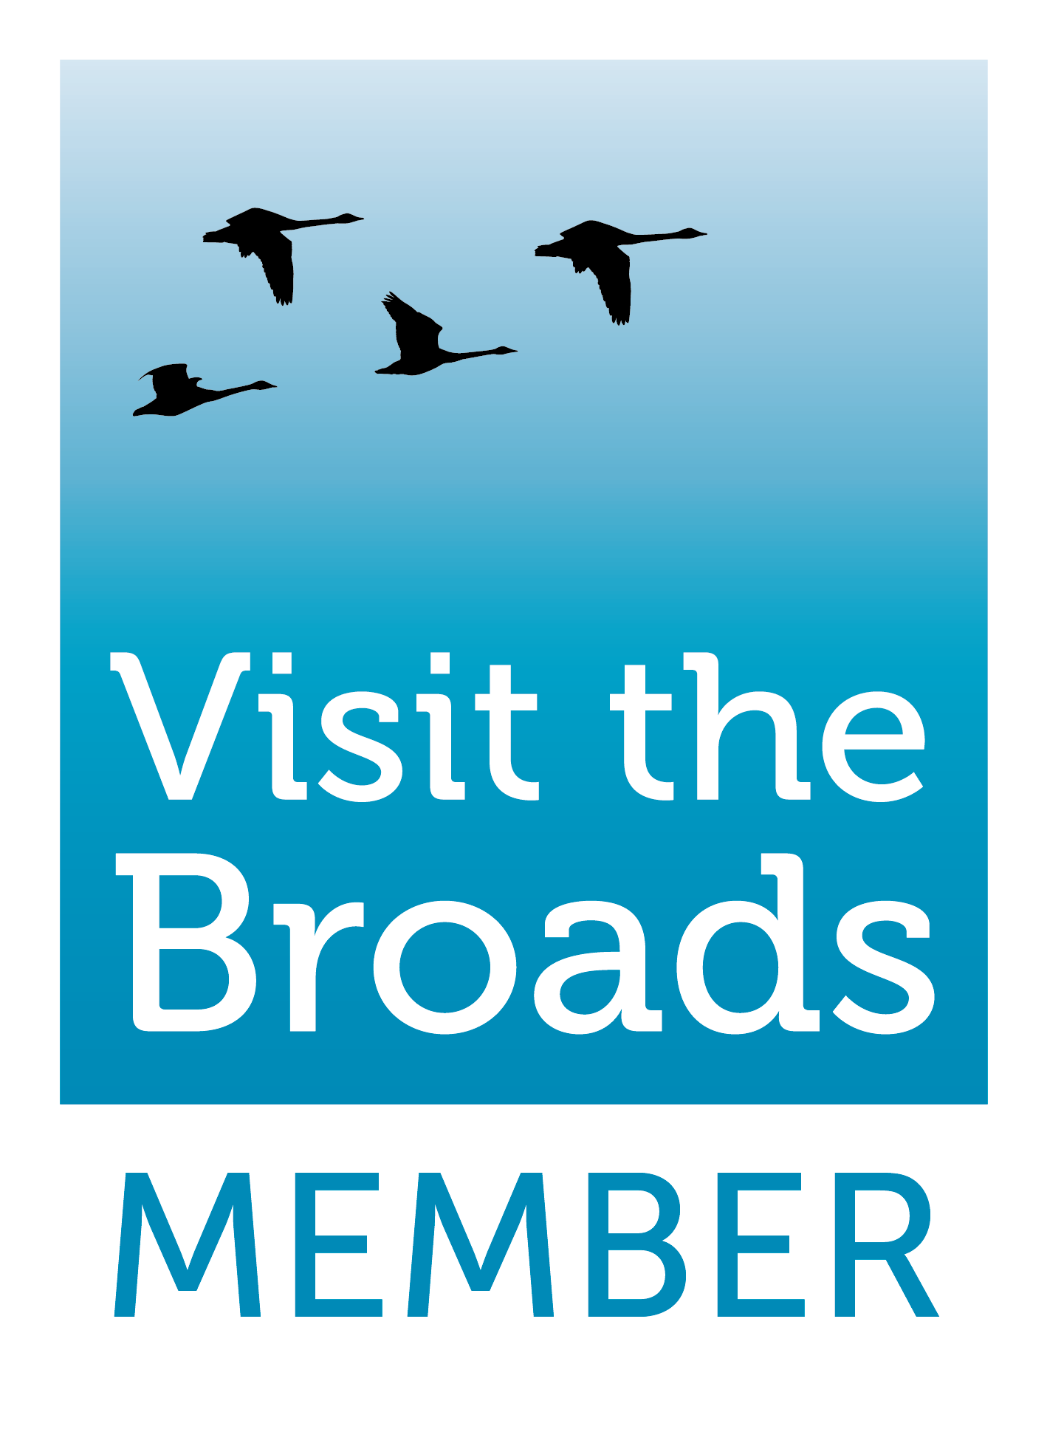
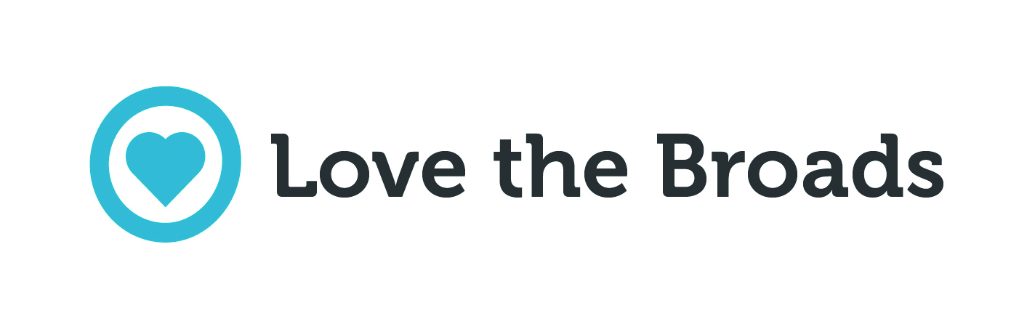
Visit the Broads Annual Membership Booking Form

Business Name: | Click to add text
Main Contact: | Click to add text
Address: | Click to add text
Click to add text |  | Postcode: | Click to add text
Telephone: | Click to add text | Email: | Click to add text
Invoice Email: | Click to add text
Business Type | Click to add text
Business Activity | Click to add text

We would like to subscribe to the Visit the Broads Annual Membership shown below.
Please note: Membership of Visit the Broads will renew automatically each year until you tell us you wish to cancel. Payment is by direct debit. You can cancel your membership and your direct debit at any time.

Annual Turnover of Business | Annual Membership Fee | Please Tick
Under £100,000 & not-for-profit organisations | £125 + VAT
Local & District Councils | £150 + VAT
£100,000 - £500,000 | £200 + VAT
Member to Member Business | £200 + VAT
Over £500,000 (or multiple website listings) | £300 + VAT

TOTAL TO BE INVOICED (+ VAT) | £ Click to add text

Signed | Click to add text | Date | Click to add text
Name | Click to add text | Position | Click to add text

Please return the completed form to: membership@visitthebroads.co.uk
IMPORTANT - Once we have received your completed booking form, you will receive an email from GoCardless with a request to sign up for direct debit payments. Once you have signed up, we will send you an invoice with notification of the payment due. This will then be taken automatically a few days later. You may stop the payments at any time.

